COSC2299 Software Engineering: Process & Tools

Semester 1, 2016

Assignment 1

# Group Members

Benjamin Lee s3494185

Reyham Soenasto s3496982

Yohanes Keanoe s3323595

Steven Bui s3381108

Contents

Group Members 1

User Stories 2

Unit Tests 2

User Guide 3

Class Diagram 4

Repository 5

Communication tools 5

# User Stories

|  |  |
| --- | --- |
| As a user I want to: | So that: |
| Open a separate window displaying station weather information | I can monitor weather of station. |
| Add/Remove a station to a favourite list | I can view them directly from the main menu |
| Open multiple windows of stations | I can view all of them simultaneously |
| Refresh a weather table | I can keep up to date with latest data from the website |

# Unit Tests

|  |  |  |
| --- | --- | --- |
| Test Method Name | Description | Status |
| testModelInitialisation() | Test the model starting initialisation by counting the number of states in model | Passed |
| testStationList() | Test the state starting initialisation by counting the number of stations in state | Passed |
| testGetStationData() | Test the station get data feature by checking if the data is null | Passed |
| testStationButton() | Test the station button from GUI by checking that the data is filled by clicking the button | Passed |
| testNowPanelFillsData() | Tests that the NowPanel displays data | Passed |
| testDayDataFormatting() | Tests the DayData class formatting functions | Passed |
| testFavesIO() | Tests the functionality of the favourites list’s persistence | Passed |
| testRemoveIO() | Tests the functionality of the favourites list’s persistence | Passed |

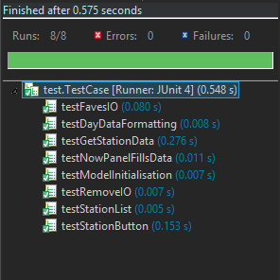

# User Guide

|  |  |
| --- | --- |
| Task | Steps involved |
| 1. Monitor weather of station | -user opens application  -selects a state  -selects a station  -station info displays to user |
| 2. Add favourite station | -user opens application  -selects a state  -selects a station  -clicks add favourite |
| 3. Remove favourite station | -user opens application  -selects a favourite  -selects delete favourite |
| 4. System stores favourites for next boot up | -user selects favourite weather station  -system stores favourite list  -system restarts with favourites saved |
| 5. Monitor weather of multiple stations simultaneously | -user selects which station they want to view  -program opens individual station info in new window |
| 7. Refresh weather table | -user opens desired station  -user clicks refresh button to update the data |

# Class Diagram

# Repository

Github

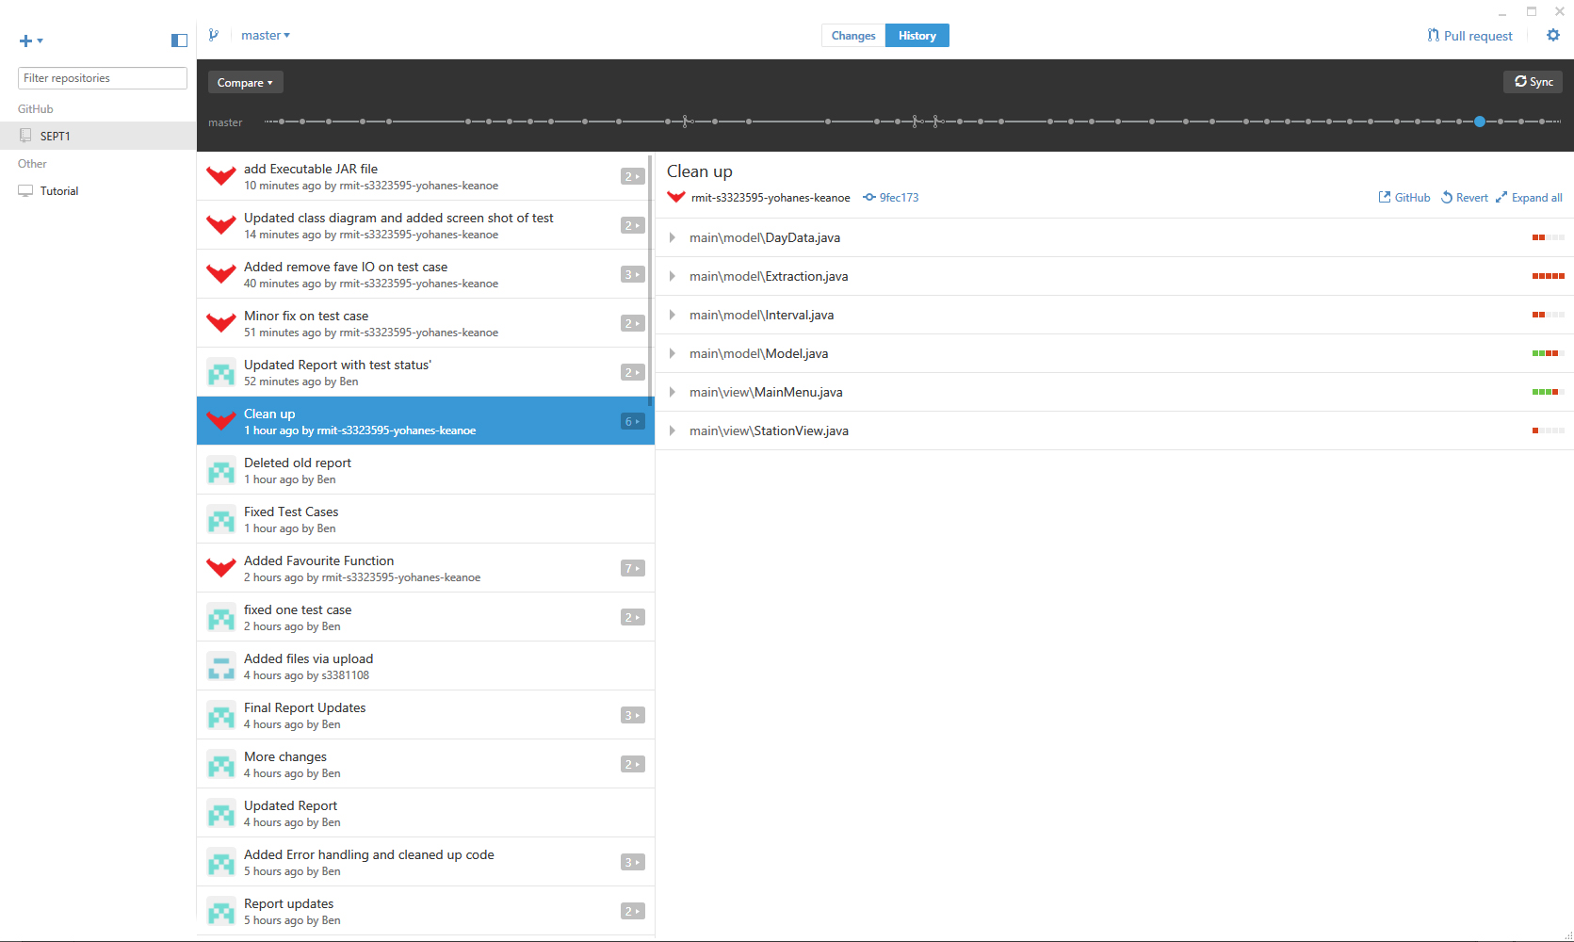

# Communication tools

Facebook

